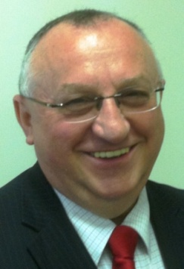
From the Events Director

The end of financial year has come and gone. When you were working through your tax records did you look at how much time and money you invested in yourself? How rounded was your development portfolio? Did you allocate funds and time for further certification, education and qualifications? What about short courses and events such as PMI chapter and breakfast meetings? In short, are you treating yourself as a micro-business; building your knowledge, skills and capabilities?

How many of us ask ourselves the question: ‘What is my personal value-add?’ The June chapter meeting on ‘Personal Branding: What Do You Stand For?’ extended this question further. How many of us took a fresh look at our on-line profiles and activity tracks? The session notes can be downloaded from the Chapter website and serve as an excellent yardstick for each of us. Do you have a tag-line or ‘hook and reel?’

The July session saw a return to the world of frameworks for programme management, benefits management and change management. Have you thought about adding some of these capabilities to your professional ‘kit bag?’ I believe that every project manager should have some understanding of Benefit Management and Change Management, and the roles of these in successful projects and programmes.

In August we returned to a personal perspective with T.U.R.N. - Four Steps to More Trust, Less Obstacles, and Smoother Communication during Change. This was presented by career change expert Clara Chorley, the founder of Clarity Unlimited. We are constantly challenged by change in our personal and professional lives. This session will provide you with the tools and inspiration to move ahead with your personal change plan.

September is a packed month with not one, but two events! On the 11th, we have a breakfast meeting at DDLS for those new to the profession or looking to take a step up into larger and more complex projects. Our presenter is Chintan Shah, a recent recipient of the PMI Australia Young Project Manager of the Year award and well-known within the chapter. Then on September 19th, we have a special event on Risk Energetics from Dr David Hillson aka The Risk Doctor.

Each of these sessions will stimulate you to look at who you are, how to relate with those around you in the profession and how to re-energise yourself and you projects! I’m excited about these sessions and look forward to seeing you there. Chapter events are a cost effective way to invest on your micro-business, so check out the events listing on the chapter website (www.pmisydney.org ) and mark your calendars so that you don’t miss out on future events.

Registration & cancellation
We aim to present informative and relevant speakers at our Chapter events, so register for events early to avoid disappointment. Later, if are unable to attend, please let me know either by email (events@pmisydney.org) or SMS at 0439 347 356. This will give those on the waiting list an opportunity to attend and ensure every seat is filled.

PDUs
Remember, you are entitled to claim 1 PDU for every PMI Sydney Chapter event that you attend. Details of how to claim your PDUs as per the new categories are on our website via the ‘Professional Development’ tab and the ‘Claiming PDUs’ option.

